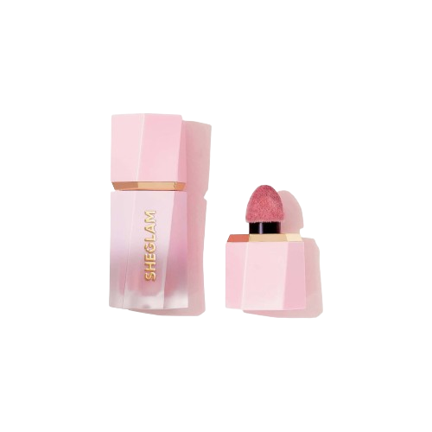

**Lakme blush is an essential cosmetic product that adds a beautiful flush of color to your cheeks, enhancing your overall complexion and radiance. With a variety of shades and formulas available, Lakme caters to diverse skin tones and preferences, allowing you to achieve the perfect level of blush intensity for any look. Whether you prefer a natural, subtle glow or a more dramatic pop of color, Lakme blushes are designed to blend seamlessly onto the skin, providing a smooth and flawless finish. With long-lasting formulas that withstand the rigors of the day, Lakme blush ensures that your cheeks stay fresh and vibrant for hours. Elevate your makeup routine and embrace a youthful, healthy glow with Lakme blush, a trusted choice for effortless beauty enhancement.**

**Lakme 28$**

**Blush**